**Laboratory Seven**



**Javier Jesús Macossay-Hernández**

**EE348L – Electronic Circuits**

**University of Southern California**

**Professor Susan Schober**

**Introduction**

In this laboratory, implementation of hand analysis and HSPICE simulations were done to understand the behavior of amplifiers. The amplifiers are built using MOSFETs. Furthermore, the amplifier was built in the lab and different tests were done to corroborate our hand calculations and simulation results.

Exercise 1

**Procedure**

The following circuit was built, a common-source amplifier. The values of the load resistances used where 100 kΩ, 10 kΩ, 1 kΩ, and 100 Ω for a 10 kHz sine wave with amplitude of 50 mV.

**Data**

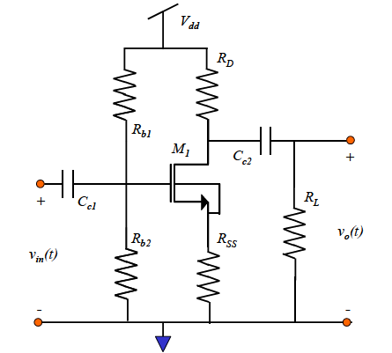

Common-Source Amplifier

|  |  |
| --- | --- |
| **gm** | 0.0224 Ω-1 |
| **Id** | 313.742 μA |
| **Vdd** | 10 V |
| **Rd** | 15.91 kΩ |
| **Rss** | 200 Ω |
| **Rb1** | 10 kΩ |
| **Rd** | 1.1 kΩ |

Values used in our circuit

|  |  |
| --- | --- |
| **RL (Ω)** | **Gain (V/V)** |
| 100 | 2.15 |
| 1k | 4.3 |
| 10k | 16.01 |
| 100k | 30.1 |
| Open | 33.6 |

Gain obtained using different values for load resistances

**Questions**

When the sine wave amplitude was increased to 100 mV, 200 mV, and 400 mV, the amplifier started clipping at 300 mV, yet at 400 mV it was completely clipped. The gain for 300 mV is 15.95 and the one for 400 mV is 14.76.

In addition, gain increases as R increases. Therefore, gain for an open load is larger than the previous gains obtained from the measurements. The more resistance, the more voltage drop is going to be across the load resistor. When recording gain for an open load, gain increases because it is essentially making the load resistor infinity.

**Discussion**

When using the value of RL = 10 kΩ, the designed circuit had a gain of 15 (V/V). The experimental results yield to a gain of 15.5 (V/V). The actual circuit yields to a 3.33% error, which is in an acceptable range.

Exercise 2

**Procedure**

A cascade amplifier was designed in pre-lab question 4. The results for load resistance values for 100 kΩ, 10 kΩ, 1kΩ, and 100 Ω were recorded while using 10 kHz sine wave with amplitude of 50 mV.

**Data**

|  |  |
| --- | --- |
| **RL (Ω)** | **Gain (V/V)** |
| 100 | 2.93 |
| 1k | 6.8 |
| 10k | 8.01 |
| 100k | 7.98 |
| Open | 8.05 |

Gain obtained using different values for load resistances

**Questions**

When using the load resistance value for 100 Ω, the gain did not agree with our hand calculations and SPICE simulations. Additionally, we fixed the circuit and were able to get a 90° phase shift that was expected.

When the input amplitude changed from 100 mV to 400 mV, the distortion in our signal was obvious. As a result, the clipping was not able to be seen.

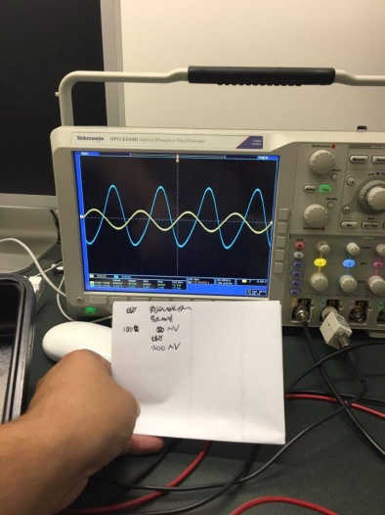

V = 200 mV, distortion can be perceived in the peaks of the single and phase shift can be observed as well.

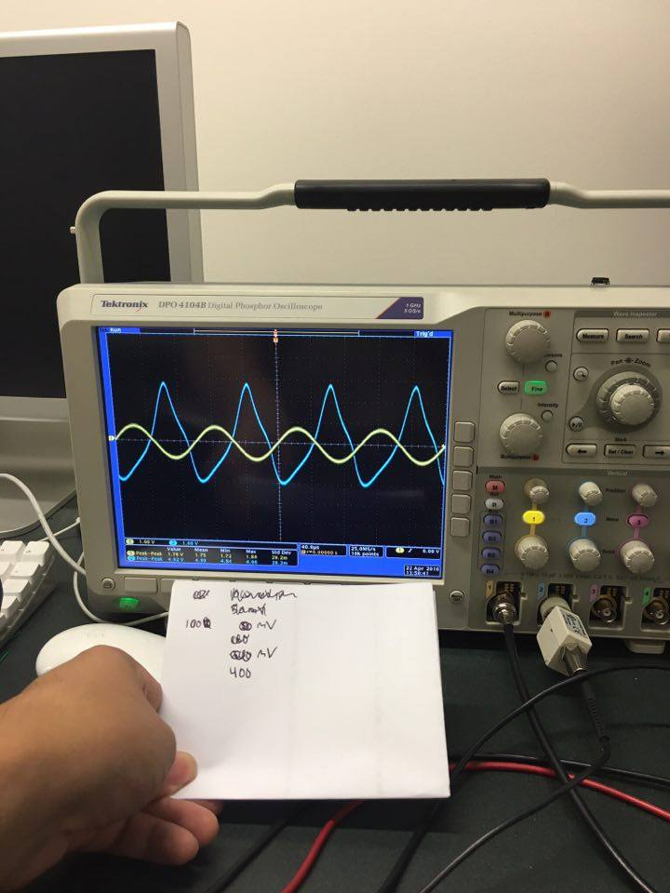

V = 400 mV, distortion is perceived and completely obvious. The distortion is due to the capacitors that do not act as shorts, just cables. Probably a different value of the capacitor was needed.

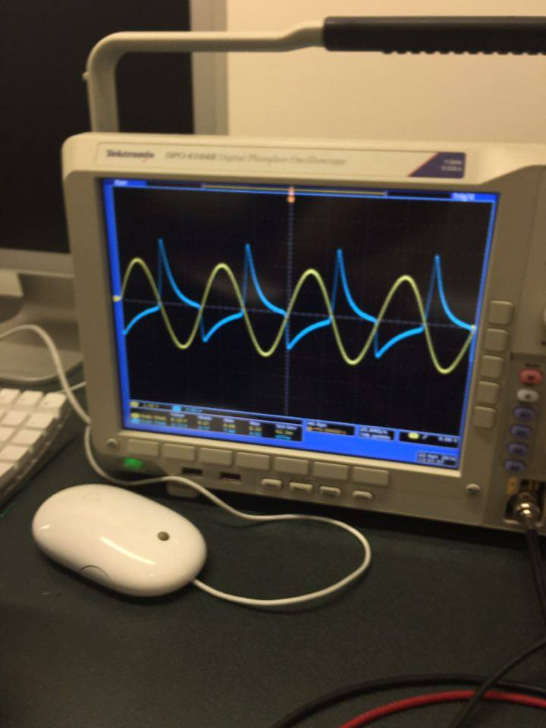

If the voltage input is above 400 mV, the signal becomes more distorted.

**Discussion**

A possible problem for the errors in our results is the capacitor. Another reason could have been that the MOSFET did not work as it was supposed to work. Since the circuit is very sensitive to the values of its components, as a result using incorrect values will make the circuit to fail.

**Conclusion**

The results clearly agree with the objective of the lab that is to learn how MOSFETs behave. In addition, we use HSpice and WaveView Analyzer to corroborate our hand calculations and our measured values.